Seth Rowan
SENG 5831
5 April 2015
PID Controller Report

Note on my controller: The units used throughout my my system are encoder counts on the motor. For the purposes of the speed controller portion, the unit is encoder counts per PID calculation interrupt. Unless otherwise noted in this report (since we do play with the calculation frequency a bit), assume the PID calculation to be occurring every 10 ms (100 Hz). This puts the maximum speed of the motor at somewhere around 74 (74 encoder counts per 10 ms) for purposes of setting the reference speed through the interface.

Also note that inputs for the PID gains (the K values) should be entered through the interface 1000 times higher than their actual value (for example, in order to get a Kp of 10, you would enter “P 10000”). This was done because I was not able to figure out how to enter floating point numbers through the interface but needed the ability to work with decimal numbers. All numbers are input as integers then divided by 1000 and cast as floats for the purpose of the PID calculation.

Note on using the interface: The interface takes in a single character command along with an integer argument. Both need to be entered in order for the command to be accepted, even if the command does not need an argument to be valid. The controller will not accept the command if both are not present (I could not figure out how to make it not require the numeric argument). The numeric argument can be positive or negative. Valid commands are:
L – toggle logging output to the screen. Numeric argument irrelevant.
V – view the variables at this instant. Numeric argument irrelevant.
R – set a reference position of encoder counts with the argument.
S – set a reference speed of encoder counts per 10 ms with the argument (note that at the current setting of running the calculation every 10 ms, the motor's top speed is about 74)
P – set the Kp gain to 1/1000 of the input argument.
I – set the Ki gain to 1/1000 of the input argument.
D – set the Kd gain to 1/1000 of the input argument.
T – toggle execution of the set up trajectory.
O – set program mode, which is used for questions 4 and 5 of this assignment.

Speed Control
1. Using only P in the PID calculation, the response is quick, but it is not possible to settle on the reference speed. With lower Kp values, the motor settles at a speed that is some proportion of the reference. (For example, with Kp = 10.0, quickly gets up to and maintains a speed that is about 75% of the target). As you increase Kp, it is able to get closer to the reference, but becomes increasingly unstable. At around Kp = 25.0, it is able to get close to the reference speed, but routinely overshoots the reference speed, which actually results in the motor reversing direction according to the way the PID calculation is carried out (when it overshoots, the calculation yields a negative number, which makes the motor reverse direction even though all we really want is for it to slow down). The motor continues at a speed close to the reference, but is not steady and the motor shakes violently.

Adding in a Ki gain stabilizes things significantly. At Ki = 1.0, response is very good and the motor settles on the reference speed very quickly. In fact, with Ki =1.0, I seems to get about the same results regardless of my Kp value, so long as that value isn't so large that causes instability as found in the previous experiment. I can even set Kp=0 and the controller still works well. The controller seems to work best with a very small, or nonexistent Kp value. If I use a Ki around 2.0 or, drastic changes in the speed, such as going from 0 to 50, will cause the board to shut down. Small changes are ok, though. With larger Ki values, such as 5.0 or higher, the speed will oscillate around the reference before settling in. At around Ki = 10.0, the motor does not settle on a speed and just oscillates, including changes in direction (evident from the direction LEDs near the motor output)

Adding in Kd does not appear to improve things. Small values of Kd, such as .5 to 2.0, don't have much effect, though it does limit the amount of overshoot before the motor settles in to its reference speed. Using a larger Kd value causes the speed maintenance to become unstable, though. At Kd = 10.0, the motor has some visible vibration from the changes. It gets worse with higher Kd values.

After experimenting with different combinations of Kd values, I have found the best response and stability with gains of Kp=0, Ki=1.0, Kd between 0 and 2.0. Ki is by far the most important variable in this scenario. This makes sense, as the the accumulation of the error is what allows the motor to maintain its speed. P and D don't seem to much more than offer a marginal improvement to the performance. If they do, it is not perceptible.
2. The gains of Kp=0, Ki=1.0, Kd=0 discussed above work very well for all speeds within the range of the capabilities of the motor and my implementation (note that my implementation allows minimum speed of 1 encoder count per 10 ms, up to about 74). Care needs to be taken when bring the motor down from a high speed as a drastic change will cause the PID calculation yield a negative result for the motor input which is interpreted as a change in direction. Quickly changing the direction of the motor output while at a high speed often causes the board to shut down, so this should be avoided. Aside from this limitation (and I did not find a gain combination that prevented this, I suspect I would need to build a safety into my program. I have not implemented this.), these gains work well.

I slowed the interrupt rate for the PID calculation to 25 Hz and experimented with my gains again. I find that my values of Kp=0, Ki=1.0, Kd=0 still work pretty well for getting to a steady target speed, but it is just a little bit more unstable. Using higher Ki values shut the board down immediately when I start the trajectory, so the calculation must be doing something more drastic.

In general, it like with doing the calculation at ¼ the frequency causes the gains to be about 4 times more potent. Where I found a Kp alone of 10.0 to get to 75% of the reference speed, I now attain that with a Kp of 2.5. It oscillates quite a bit around that point before settling into that speed though. Where I found the ideal Ki to be about 1.0 at 100 Hz, I now get that performance with a Ki of .25. Kd still does not seem to have much effect on performance unless I give it too high a value, in which case ithe motor's ability to maintain speed becomes very unstable. This seems to happen with any value of Kd over 2.0.

What I do notice at this frequency is that when I use gains that cause it become unstable, it is much more unstable than it was at 100 Hz. It oscillates much more than I was able to get it with any value when I ran the interrupt at 100 Hz.

Just for fun, I also tried running the interrupt at 200 Hz. I was not able to find a difference in performance at this frequency from when I had it set at 100 Hz, other than that the gain value now appear to be about half as potent, so need to be higher to get the same behavior. This does put further limitation on the granularity of my speed control, as I am am limited to a range of 0 to about 32 counts per interrupt.

In order to give the best compromise between performance and control granularity, I believe 100 Hz for the speed control calculation to be the best way to go.

Position Controller
3. It is very difficult to get the controller to reach the target at low speed with just PD. With low gains, I can get close to the reference, but it reaches a point where the torque value coming out of the PID calculation is too small to actually move the motor. With a Kp of .2, the motor does not get to full speed (going from 0 to 1000 encoder counts), but it also does not get to the reference before the torque falls below a value that cannot move the motor. Kd, as a damper, does not aid in this. Using a larger value slows the motor, but that just exacerbates the problem of it reaching the reference. At around Kp=.45 I can get the motor to reach the target and it actually overshoots just a little bit. I have not found a PD combination that reliably

Adding in I helps the motor reach the reference, but the value must be kept very small in relation to Kp or the motor ends up overshooting the reference and oscillating around it. I can get pretty good accuracy with Kp = .3, Ki=.006, Kd=.5, but it still tends to be a few encoder counts off.

It is actually easier to get better accuracy with larger values of Kp and Kd, and it reaches the target quickly. Kp=4.0 and Kd=4.0. It does overshoot by a few encoder counts, but corrects itself quickly. Introducing a small value for Ki will cause it to overshoot by more, but it slowly corrects itself. Ki=.05 going from 0 to 1000 counts will typically overshoot to about 1007, but it will slowly come back to the reference. A larger Ki, say around.5, will cause it to overshoot by more, but it will more quickly correct itself.

The PD control by itself does not overshoot by much, which may be ideal in some circumstances, but it does not allow for very fine grains of control. It is very accurate at making large movements, such as around 1000 encoder counts. But it is unable to make very fine movements, such as just 1 or 2 encoder counts. In order to do this, you need to add in a Ki value of some kind. It doesn't have to be large, though any value will cause more overshoot and a smaller Ki will mean a slower correction. A larger Ki means a larger degree of overshoot. So the best solution depends on whether is more important to get to the reference quickly, or ensure the controller does not go too far past its target.

A good compromise between these two goals has led me to use values Kp=4.0, Ki=.25, Kd=10.0. I experimented with larger Kd values to limit the overshoot, but that also caused more oscilation before settling on the reference value. Below is a chart of the motor making one full rotation (2256 encoder counts):

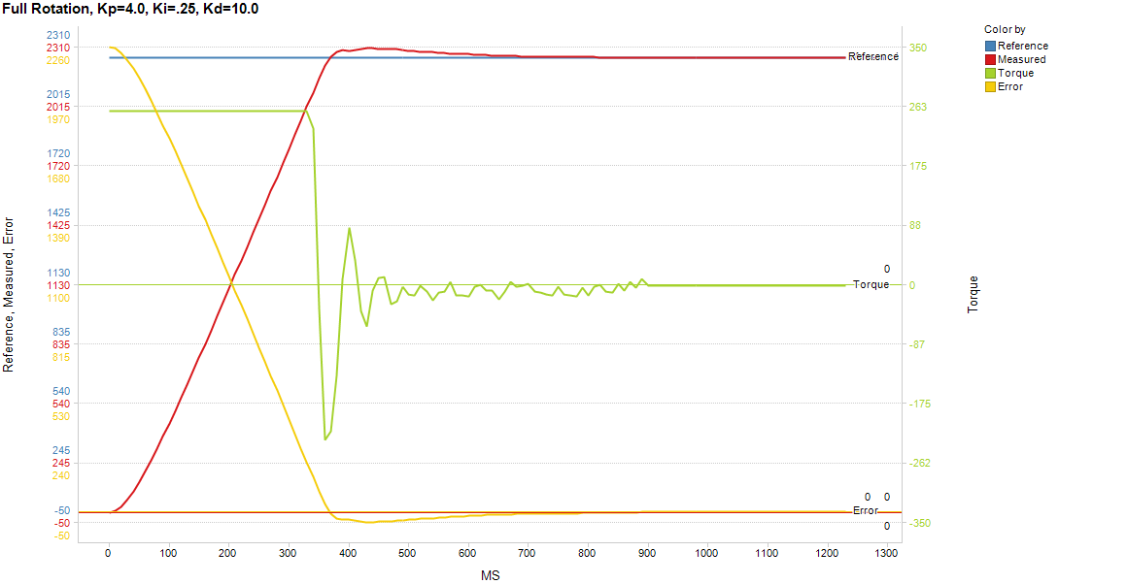

As seen here, these values allow the motor to settle into its reference position in .89 seconds while overshooting the reference by just 50 encoder counts (about 8 degrees on the drive shaft). There is some rapid oscillation shown in the Torque line, but this is not readily apparent to the human observer without looking at the specific output values.

4. For this experiment, I continue to use the values I found in the last step to work well: Kp=4.0, Ki=.25, Kd=10.0. Graphed are the results running in program mode, which rotates the motor 90 degrees (564 counts), then back 360 degrees (to -1692 counts), and finally forward 5 degrees (to -1660 counts).

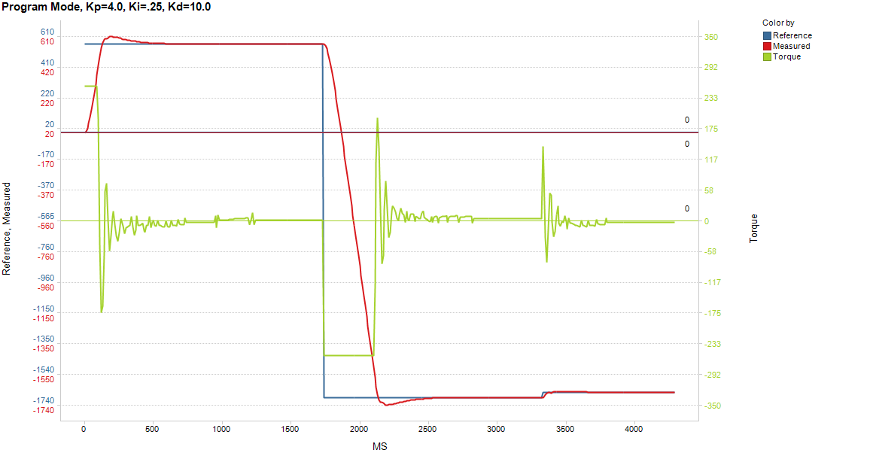
Again, there is some oscillation before the motor settles in on its reference position, but it is able to reach the position quickly and can land exactly on target.

5. As discussed before, I am unable to get exactly to the reference point using low gains. The lowest gains I have been able to have some success with are Kp=.3, Ki=.006, Kd=.5. In order to make this experiment possible, I had to increase the tolerance to allow the program to proceed to the next position if it could get within 5 encoder counts of the reference. I also needed to increase the wait time before moving onto each position to 1 second.

This graph shows the progression with “very slow” gains of Kp=.3, Ki=.006, Kd=.5:

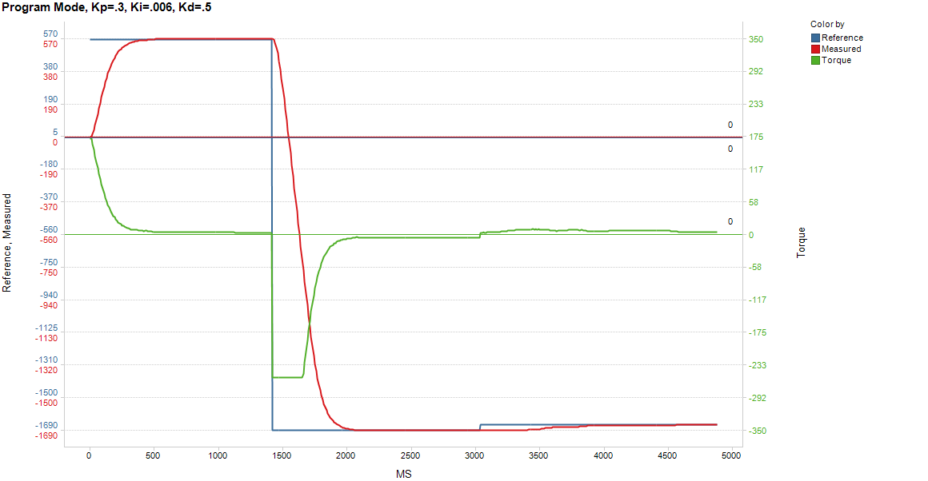
The transitions are much smoother with these values, and there is no oscillation before landing near the target. It cannot land exactly on target, though. Interestingly, large moves, such as making the full rotation, happen almost as fast as though do with low gains. Even more interestingly, it actually takes longer for the motor to make a small move than it does to make a large move. Note that it is able to make the second move of a full rotation in just a little over half a second, but it takes it almost a full second to make the move of just 5 degrees (and it still does not land within the tolerance zone; I had to cut the experiment short).

I had great difficulty in getting the program to run in the mode with the 3 prescribed positions without shutting down the board. While I was able to get the program to run through the 3 positions with low gains, as shown above, and can consistently get it to work with high gains as shown in question 4, I was unable to find a combination in between that did not result in a board shutdown. It usually occurs on its way t the 2nd position right around the point where the motor needs to turn around after overshooting the reference point. After playing around with many different values, including the limit I put on the size of the error-sum in the PID calculation, I cannot account for this behavior. Nothing in the variable read-outs suggest anything is out of whack. I do, however, have to move on.

This graph depicts the partial run with Kp=.6, Ki=.012, Kd=1.0:

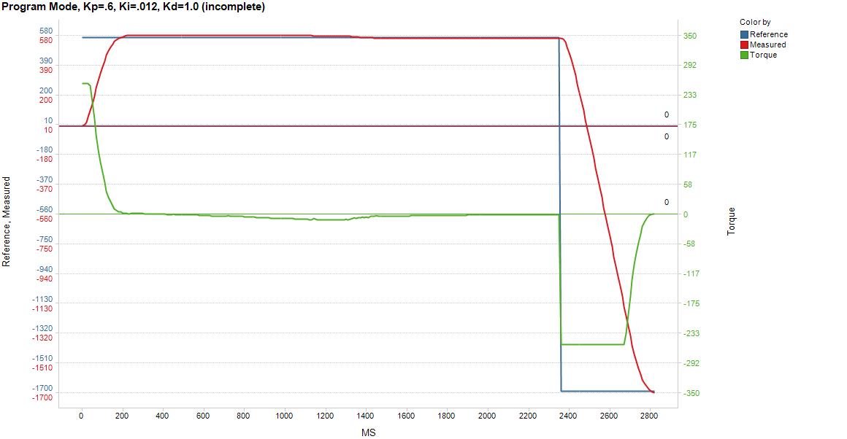

With somewhat larger gains, we still see it moving fairly smoothly, though you do start to see some oscillation in the torque value before it settles into the first position. Unfortunately, the board shut down after reaching the second position, so no more can be gathered from this experiment.

Overall conclusions
With larger gains, you can get a quicker response time, but you also get more oscillation before it reaches the reference value. This may not be a problem if the goal is just to reach the reference quickly, but might be undesirable if higher precision is required. The Polulu motor being used here has a severe limitation in that it needs to receive a minimum amount of power in order to move at all. This prevents it from reaching its positional target if low gains are used, as the output of the PID calculation will not yield a value large enough to move the motor. These motors should not be used if high precision movements are required.

Another observation I see in these experiments is that I is the most important variable in the PID calculation for maintaining a constant motion, while P and D are the most important in a positional stop-and-hold controller. When maintaining constant speed, it is necessary to have the accumulated error in the I variable as that will cause a constant value to come out of the PID calculation. This is how it maintains speed. When the goal is to reach and stop on a given position, however, it is more important to use P to get to the position and D to help slow it down as it gets close so it does not overshoot. Some I is helpful here in order to correct the position if overshoot does occur, but too much will be detrimental, as it will cause the controller to take longer to settle into the reference position.

